1. Find what is the task priority numbering for the RTOS YOU are using eg. Higher the
number higher the priority or vice-versa. Find the range of priority that can be assigned to

ans –
higher the number , higher is the priority of the task .
Each task is assigned a priority from 0 to (configMAX_PRIORITIES -1) .
if configUSE_PORT_OPTIMISED_TASK_SELECTION is set to 1 in
FreeRTOSConfig.h then configMAX_PRIORITIES cannot be higher than
32
in all other case configMAX_PRIORITIES can take any value with reason
but for reasons of RAM usage efficiency should be kept to the minimum
value actaully necessary .

Q3 . Find the APIs in your RTOS that provides timestamp and use it to print the periodic task.
Observe the jitter in the timestamp vs the periodicity. Enhance the code to 10 periodic tasks
with different periodicity. Futher observe the jitter in each of the task.
ANSWER:-Jitter:-The amount of error in the timing of a task over subsequent iterations of a program or loop is referred to as jitter.
Real-time operating systems are optimized to provide a low amount of jitter when programmed correctly; a task will take very close to the same amount of time to execute each time it is run.

Jitter is typically on the order of a microsecond to a few tens of microseconds for hard real-time operating systems, and ranges from milliseconds to seconds in the worst case for soft real-time operating systems

Q5. Swap the priority and observe the changes in the output. What is your conclusion on the sequence of printing the messages.
ANSWER:- You can change the priority temporarily and persistently using steps ... you check the output of the swapon -s command, you would see the Priority column.

Q6. What are the maximum number of tasks that can be created on the RTOS you are using?
Is it limited by the RTOS design or underlying hardware resources or both.
ANSWER :- In RTX51 Full RTOS, a maximum of 256 tasks (0... 255) can be defined. However, only 19 tasks can be active at the same time.
In RTX TINY RTOS, a maximum of 16 tasks (0...15) can be defined.

Q7 . What is the scheduling algorithm used by your RTOS?

ANSWER:- the most popular scheduling algorithms that are used in CPU scheduling. Not all of them are suitable for use in real-time embedded systems. Currently, the most used algorithms in practical RTOS are non-preemptive scheduling, round-robin scheduling, and preemptive priority scheduling.

Q8. List the customization options for creating a task for the RTOS you are using. eg. Priority etc.

ANSWER:- FreeRTOS is customised using a configuration file called FreeRTOSConfig.h. ... The application creates tasks that run at the idle priority.

Q9. Find the fields that are maintained in the Task Control Block / Process Control Block of the
RTOS you are using.
ANSWER:-
the process control block(PCB) is used to track the process's execution status.
A process control block (PCB) contains information about the process, i.e. registers, quantum, priority, etc. The process table is an array of PCB’s, that means logically contains a PCB for all of the current processes in the syste

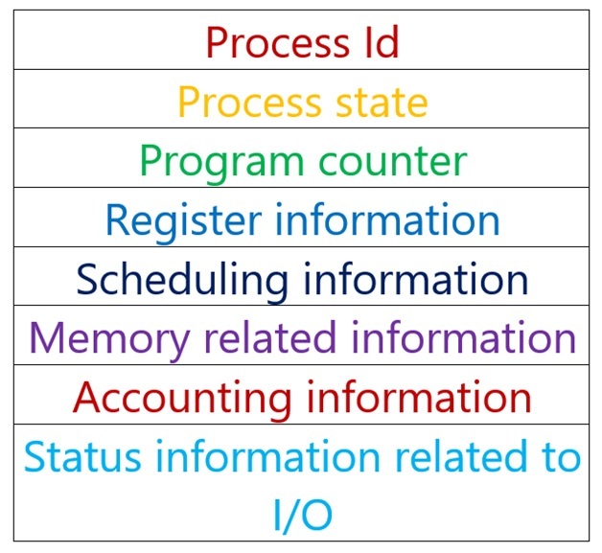

Q10. Draw a process or task state diagram for the RTOS
ANSWER:-
.Running
When a task is actually executing it is said to be in the Running state. It is currently utilising the processor. If the processor on which the RTOS is running only has a single core then there can only be one task in the Running state at any given time.
- Ready
Ready tasks are those that are able to execute (they are not in the Blocked or Suspended state) but are not currently executing because a different task of equal or higher priority is already in the Running state.
- Blocked
A task is said to be in the Blocked state if it is currently waiting for either a temporal or external event. For example, if a task calls vTaskDelay() it will block (be placed into the Blocked state) until the delay period has expired - a temporal event. Tasks can also block to wait for queue, semaphore, event group, notification or semaphore event. Tasks in the Blocked state normally have a 'timeout' period, after which the task will be timeout, and be unblocked, even if the event the task was waiting for has not occurred.
Tasks in the Blocked state do not use any processing time and cannot be selected to enter the Running state.

- Suspended
Like tasks that are in the Blocked state, tasks in the Suspended state cannot be selected to enter the Running state, but tasks in the Suspended state do not have a time out. Instead, tasks only enter or exit the Suspended state when explicitly commanded to do so through the vTaskSuspend() and xTaskResume() API calls respectively.
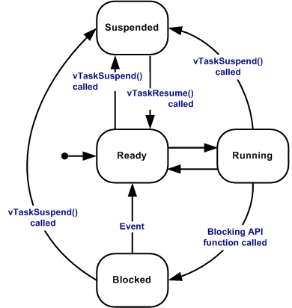

Q11. What is the API for deleting a task?
ANSWER:-
If enough users request a capability that requires a new API, then we add the API.
vTaskDelete():This function is used to delete as task. We need to pass the taskHandle of the task to be deleted.
To delete the own task we should pass NULL as parameter.

Q12. What are the APIs provided by your RTOS for enabling and disabling the interrupts?
ANSWER:-
1.xTaskCreate(): This interface is used to create a new Task, if the task is successfully created then it returns pdPass(1) or else errCOULD_NOT_ALLOCATE_REQUIRED_MEMORY(-1).
2.vTaskDelay(): This function is used to delay/block the task for specified delay time(ticks). INCLUDE_vTaskDelay needs to be set to 1 in FreeRtosConfig.h file for using this function.

Q23. Write a RTOS application to manage resources using mutual exclusion.
ANSWER:-
A mutual exclusion (mutex) semaphore is a special binary semaphore that supports ownership, recursive access, task deletion safety, and one or more protocols for avoiding problems inherent to mutual exclusion.
As opposed to the available and unavailable states in binary and counting semaphores, the states of a mutex are unlocked or locked (0 or 1, respectively).
A mutex is initially created in the unlocked state, in which it can be acquired by a task.
After being acquired, the mutex moves to the locked state.
Conversely, when the task releases the mutex, the mutex returns to the unlocked state. Note that some kernels might use the terms lock and unlock for a mutex instead of acquire and release.
Depending on the implementation, a mutex can support additional features not found in binary or counting semaphores.
Q24. Write a RTOS application to demonstrate a priority inversion problem. If your RTOS sup-
ports priority inheritance or priority ceiling, use it to solve the priority inversion problem.
ANSWER:-
Priority inversion is a situation in which a low-priority task executes while a higher priority task waits on it due to resource contentions.
A high task priority implies a more stringent deadline. In a priority-based, preemptive scheduling system, the kernel schedules higher priority tasks first and postpones lower priority tasks until either all of the higher priority tasks are completed or the higher priority tasks voluntarily relinquish the CPU. In real-time embedded systems, the kernel strives to make the schedulability of the highest priority task deterministic. To do this, the kernel must preempt the currently running task and switch the context to run the higher priority task that has just become eligible, all within a known time interval. This system scheduling behavior is the norm when these tasks are independent of each other. Task interdependency is inevitable when tasks share resources and synchronizing activities. Priority inversion occurs when task interdependency exists among tasks with different priorities.

